Ideation Phase
Empathize & Discover

Date | 01 January 2026
Team ID | 4967
Project Name | Shopez
Maximum Marks | 4 Marks

Empathy Map Canvas:
Understand the needs, frustrations, and behaviors of online shoppers seeking a fast, beautiful, and reliable e-commerce experience.

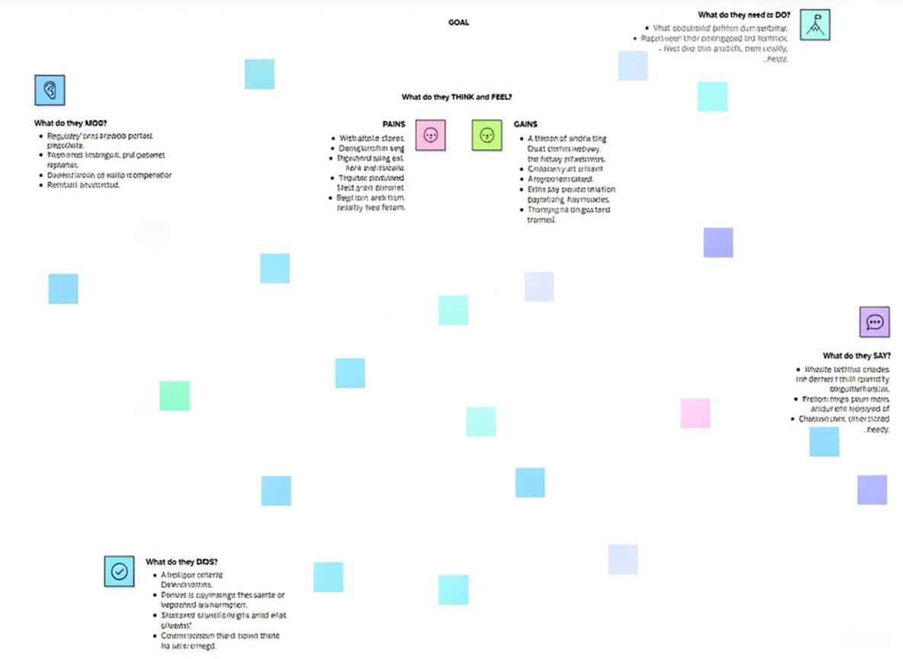

Reference: https://www.mural.co/templates/empathy-map-canvas

